|  |  |  |  |
| --- | --- | --- | --- |
| 1 | | 103,416 | |
| **NUMERO DE FRONTERAS** | | **ENERGIA AGREGADA** | |
|  | | | |
| 207,667,940 | 73 | | 7,572,109 |
| INGRESO 2019 | DÍAS CERTIFICADOS 2019 | | ENERGIA RESPALDADA 2019 |
|  | | | |
| 421,167,638 | 163 | | 16,013,687 |
| INGRESO 2020 | DÍAS CERTIFICADOS 2020 | | ENERGIA RESPALDADA 2020 |
|  | | | |
| 289,648,864 | 138 | | 12,860,320 |
| INGRESO 2021 | DÍAS CERTIFICADOS 2021 | | ENERGIA RESPALDADA 2021 |

**HISTORICO REINTEGRO DDV**

|  |  |  |  |
| --- | --- | --- | --- |
|  | **2019** | **2020** | **2021** |
| **ENE** | - | 25.63 | 28.22 |
| **FEB** | - | 41.45 | 8.43 |
| **MAR** | - | 98.57 | 25.38 |
| **ABR** | - | - | 6.64 |
| **MAY** | - | 9.57 | 59.54 |
| **JUN** | - | 10.98 | 41.96 |
| **JUL** | - | 35.23 | 39.12 |
| **AGO** | - | 36.09 | - |
| **SEP** | 29.04 | 4.53 | 42.83 |
| **OCT** | 67.87 | 67.32 | 37.53 |
| **NOV** | 86.99 | 33.07 | - |
| **DIC** | 23.77 | 58.73 | - |

**Los valores de la tabla están en millones de COP**

**REINTEGRO MECANISMO DDV OCTUBRE 2021**

|  |  |  |  |  |  |
| --- | --- | --- | --- | --- | --- |
| FECHA | TIPO DIA | CANTIDADES RESPALDO | PRECIO PONDERADO USD | TRM | PNETO |
| 2021-10-01 | Viernes | 103,268 | 5.98 | 3,784.44 | 2,094,000 |
| 2021-10-02 | Sábado | 103,412 | 5.98 | 3,784.44 | 2,096,919 |
| 2021-10-03 | Domingo - Festivo | 103,409 | 5.98 | 3,784.44 | 2,096,859 |
| 2021-10-04 | Lunes | 103,412 | 5.98 | 3,784.44 | 2,096,919 |
| 2021-10-05 | Martes | 101,108 | 5.98 | 3,784.44 | 2,050,201 |
| 2021-10-06 | Miércoles | 102,017 | 5.98 | 3,784.44 | 2,068,633 |
| 2021-10-07 | Jueves | 103,361 | 5.98 | 3,784.44 | 2,095,885 |
| 2021-10-08 | Viernes | 103,265 | 5.98 | 3,784.44 | 2,093,939 |
| 2021-10-09 | Sábado | 103,409 | 5.98 | 3,784.44 | 2,096,859 |
| 2021-10-10 | Domingo - Festivo | 103,409 | 5.98 | 3,784.44 | 2,096,859 |
| 2021-10-11 | Lunes | 103,265 | 5.98 | 3,784.44 | 2,093,939 |
| 2021-10-25 | Lunes | 101,108 | 5.98 | 3,784.44 | 2,050,201 |
| 2021-10-26 | Martes | 103,408 | 5.98 | 3,784.44 | 2,096,838 |
| 2021-10-27 | Miércoles | 103,412 | 5.98 | 3,784.44 | 2,096,919 |
| 2021-10-28 | Jueves | 101,108 | 5.98 | 3,784.44 | 2,050,201 |
| 2021-10-29 | Viernes | 102,017 | 5.98 | 3,784.44 | 2,068,633 |
| 2021-10-30 | Sábado | 103,361 | 5.98 | 3,784.44 | 2,095,885 |
| 2021-10-31 | Domingo - Festivo | 103,265 | 5.98 | 3,784.44 | 2,093,939 |

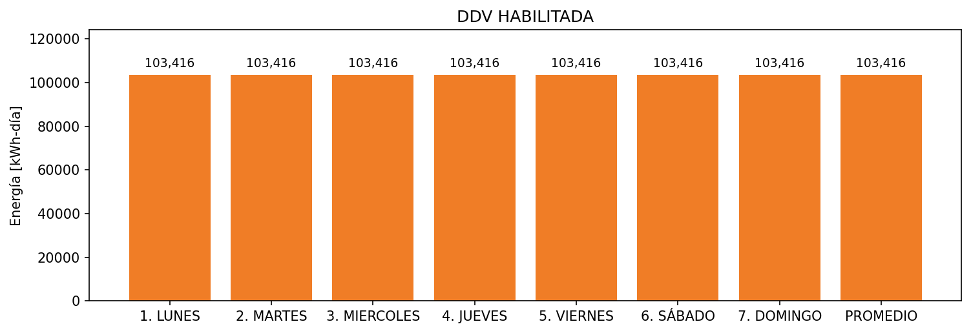

|  |  |  |  |  |  |  |  |  |  |
| --- | --- | --- | --- | --- | --- | --- | --- | --- | --- |
| **FRONTERA** | **COD SIC** | **FRT DDV** | **TIPO DDV** | **PROMEDIO** | **PRÓXIMA ACTUALIZACIÓN** | **MARGEN DE ERROR** | **ÚLTIMA PRUEBA DDV** | **DÍAS PARTICIPACIÓN** | **FECHA REFERENCIA PRÓXIMA PRUEBA DDV** |
| MALTERIA TROPICAL S.A. - CARTAGENA | Frt01581 | Frt33219 | LBC | 103,416 | 2022-02-16 | 3,77 | 2021-08-29 | 36.0 | 2022-01-31 |